**CBA 2018: Assignment II**

**Q4 –**

Z = 38.920 (0,0,5.5,0) using LP relaxation

X1 = 1 X1 = 0

Z = 21.76 (1,0,1.68,0) Same solution

X2 = 0 X2 = 1 X2 = 0 X2 = 1

Z = 21.76 Z Z= 14.8 Same Z = 31.96(0,1,4.2,0)

X3= 0 X3=1

Z = 20.5 Z = 21.25 X3 = 0 X3 = 1 X3 =0 X3 = 1

Z = 34.75 Z = 35.5

Q5 -- Node 0 Using LP relaxation , Z = 17 and (1,0.5,0.5,.5)

X1 = 0 X1 = 1

Z = 14 (0,1,1,1) -> incumbent solution Z = 17 - Same solution

X2 = 0 X2 = 1 X2 = 0 X2 = 1

(1,0,1,0) Z =17 (1,1,0,0)Z = 12

X3 = 0 X3 = 1

Z= 15(1,0,0,1) Z = 17

(1,0,1,0)

Z = 17 (1,0,1,0) Infeasible Solution

Yes, Questions 4 and 5 are same , objective function is same and variables are binary.

Q6 :

Using LP relaxation – Z = 320 (3.6 , 1.4)

X1 <= 3 X1 >=4

Z= 500 Z = 333.33

(3, 3.5) ( 4, 1.33)

X2<= 1 X2>=2

33 Z= 400 z = 400

(6,1) (4,2)

Graphical solution:

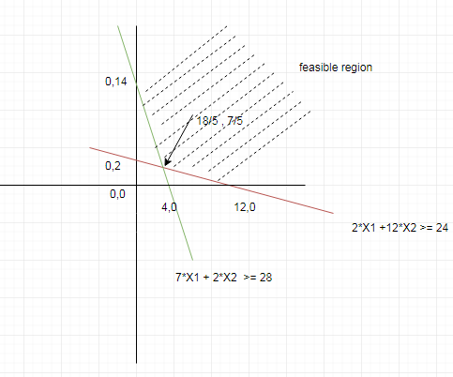

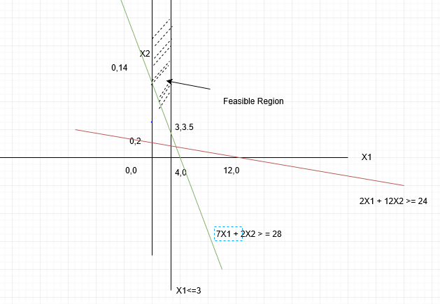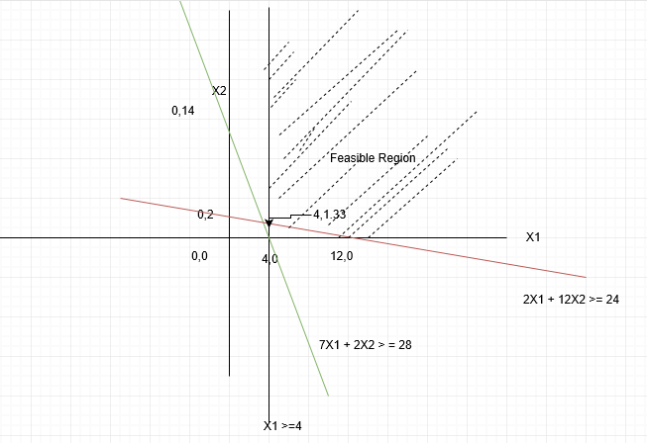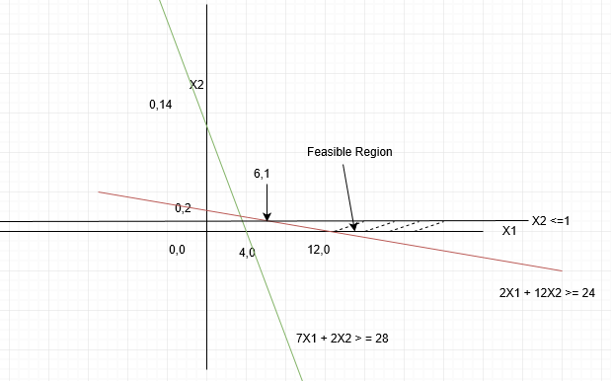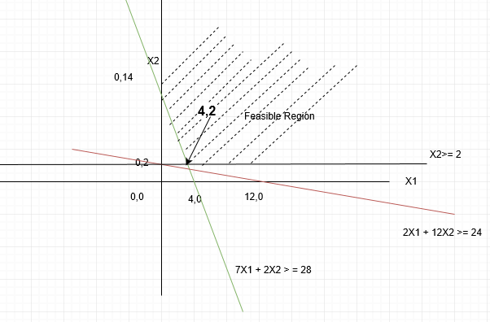

Q8 –

Using Hungrarian algorithm -

|  |  |  |  |  |  |  |
| --- | --- | --- | --- | --- | --- | --- |
|  | A | B | C | D | E | F |
| 1 | 5 | 7 | 6 | 4 | 9 | 0 |
| 2 | 8 | 10 | 3 | 4 | 7 | 0 |
| 3 | 6 | 11 | 5 | 4 | 7 | 0 |
| 4 | 5 | 8 | 7 | 3 | 9 | 0 |
| 5 | 3 | 6 | 4 | 2 | 7 | 0 |
| 6 | 3 | 7 | 5 | 3 | 7 | 0 |

Minimum value in each row – 0, table will remains same

Minimum value in each column is 3,6,3,2,7,0

After subtracting the minimum values from each column – the table is ->

|  |  |  |  |  |  |  |
| --- | --- | --- | --- | --- | --- | --- |
|  | A | B | C | D | E | F |
| 1 | 2 | 1 | 3 | 2 | 2 | 0 |
| 2 | 5 | 4 | 0 | 2 | 0 | 0 |
| 3 | 3 | 5 | 2 | 2 | 0 | 0 |
| 4 | 2 | 2 | 4 | 1 | 2 | 0 |
| 5 | 0 | 0 | 1 | 0 | 0 | 0 |
| 6 | 0 | 1 | 2 | 1 | 0 | 0 |

Count of Assigned zeroes = 5 and it equal to number of lines.

For optimized solution , there should be 6 assigned zeroes , one in each row and column

The iteration will stop , once no of assigned zeroes = no of rows.

1. Subtract 1 from each uncut cell. And add 1 to the cell, which has intersection of lines.

|  |  |  |  |  |  |  |
| --- | --- | --- | --- | --- | --- | --- |
|  | A | B | C | D | E | F |
| 1 | 2 | 0 | 2 | 1 | 2 | 0 |
| 2 | 6 | 4 | 0 | 2 | 1 | 1 |
| 3 | 3 | 4 | 1 | 1 | 0 | 0 |
| 4 | 2 | 1 | 3 | 0 | 2 | 0 |
| 5 | 1 | 0 | 1 | 0 | 1 | 1 |
| 6 | 0 | 0 | 1 | 0 | 0 | 0 |

Repeat the process of assigning zeroes in each row and column such that the optimized number of assigned cells are 6.

There are 2 solutions to this problem:

|  |  |  |  |  |  |  |
| --- | --- | --- | --- | --- | --- | --- |
|  | A | B | C | D | E | F |
| 1 | 2 | 0 | 2 | 1 | 2 | 0 |
| 2 | 6 | 4 | 0 | 2 | 1 | 1 |
| 3 | 3 | 4 | 1 | 1 | 0 | 0 |
| 4 | 2 | 1 | 3 | 0 | 2 | 0 |
| 5 | 1 | 0 | 1 | 0 | 1 | 1 |
| 6 | 0 | 0 | 1 | 0 | 0 | 0 |

Jobs assigned to Machine are :

|  |  |
| --- | --- |
| A | 6 – 3 HRS |
| B | 5 – 6 HRS |
| C | 2 – 3 HRS |
| D | 4 – 3 HRS |
| E | 3 – 7 HRS |
| F | 1 – 0 HRS |

Number of hours required to perform each job = 22 Hrs

|  |  |  |  |  |  |  |  |
| --- | --- | --- | --- | --- | --- | --- | --- |
|  | A | B | C | D | E | F |  |
| 1 | 2 | 0 | 2 | 1 | 2 | 0 |  |
| 2 | 6 | 4 | 0 | 2 | 1 | 1 |  |
| 3 | 3 | 4 | 1 | 1 | 0 | 0 |  |
| 4 | 2 | 1 | 3 | 0 | 2 | 0 |  |
| 5 | 1 | 0 | 1 | 0 | 1 | 1 |  |
| 6 | 0 | 0 | 1 | 0 | 0 | 0 |  |

Jobs assigned to Machine are :

|  |  |
| --- | --- |
| A | 6 – 3 hrs |
| B | 1 – 7 hrs |
| C | 2 – 3 hrs |
| D | 5 – 2 hrs |
| E | 3 – 7 hrs |
| F | 4 -0 hrs |

Number of hours required to perform each job = 22 hrs

Q7 -

W2= 6 B3 = -4

W1= 9B3 = -4

B2=2 w2 

B1=5

3, X12 = 5

5

X24 = 3 6 , X23 = 4

B4 = -3

B3 = -4

W4=1B3 = -4

W3= 0B3 = -4

**In MCNFP, problem is balanced if Total supply = Total demand**

**5 + 2 = 3+ 4 = 7**

**Total supply >= 0**

**Cij = per-unit shipping cost**

**Objective function – To minimize total shipping cost**

**Variables – Xij be the units shipped along the arc.(I 🡪 J).**

**X12 = Units shipped from 1 to 2**

**X23 = Units shipped from 2 to 3**

**X43 = Units shipped from 4 to 3**

**X24 = Units shipped from 2 to 4**

**X14 = Units shipped from 1 to 4**

**Minimize Objective function -> Z = 3 *X12 + 6 *X23 + 2 *X43 + 5 *X24**

**Mathematical formulation of constraints is :**

**X12 + X14 = 5**

**-X12 + X23 + X24 = 2**

**-X23 – X43 = -4**

**-X14 - X24 + X43 = -3**

**X(I 🡪 J) >= 0 for all (i,j)**

**For Balanced problem, Sum of RHS vector will be 0.**

**For first iteration, find Xij 🡪**

**X12 = 5, X24 = 3, X23 = 4**

**Find duals for the given problem:**

**For all basic arcs 🡪 Wi –Wj < = Cij for all (i,j)**

**Every basic feasible solution is spanning tree with M – 1 arcs.**

**Begin with W3 = 0,**

**Total shipping cost = X12 *C12 + X24*C24 + X23*C23 = 15 + 15 + 24 = 54**

**Compute reduced cost for all nonbasic arcs, it should be negative, RCij = wi**

**Cost of Non- basic arcs => RC14 = W1 – W4 – C14 = 7**

* **RC43 = W4 – W3 – C43 = -1**

Entering variable – X14 has most +ve reduced cost and there will be decrease in shipping cost by 21

Leaving variable -

W2= 6 B3 = -4

W1= 9B3 = -4

B2=2 w2 

B1=5

--

+ 5

X24 = 3 -- 6 , X23 = 4

B4 = -3

B3 = -4

W4=1B3 = -4

W3= 0B3 = -4

5 --

1 +

3--

**{5 -**

**3 - } --🡪 3-- is minimum .**

**Entering node 1 to 4, leaving node is 2 to 4**

**Next iteration 🡪**

W2= 6B3 = -4

W1= 9B3 = -4

B2=2 w2 

B1=5

X12 = 2

X14 = 3 X23 = 4

B4 = -3

B3 = -4

W4=8B3 = -4

W3= 0B3 = -4

**Compute reduced cost for all nonbasic arcs, it should be negative, RCij = wi**

**Cost of Non- basic arcs => RC24 = W2 – W4 – C24 = 6-8-5 = -7**

* **RC43 = W4 – W3 – C43 = 8-2 = 6**

**Node 43 will be taken forward in iteration.**

2 --

1 + 4 --

**+**

**Q9 – Using Minimum Weight Spanning Tree algorithm.**

**Using Kruskal algorithm**

1. **Sort the edges on the basis of minimum proability.**
2. **Take those edges which have least probability of interception and do not form a cycle.**
3. **Iterate the process until the total number of edges are N -1.**

**N = no of vertices.**

**12-10 🡪 0.03 3-9 🡪 0.06 4-3 🡪 0.08 1-4 🡪 0.12 7-10 🡪 0.15**

**6-11 🡪 0.04 8-12 🡪 0.06 5-7 🡪 0.09 7-11 🡪 0.12 2-8 🡪 0.16**

**7-9 🡪 0.04 11-12 🡪 0.07 7-8 🡪 0.10 8-9 🡪 0.14 4-11 🡪 0.17**

**1-5 🡪 0.05 4-7 🡪 0.07 6-4 🡪 0.10 5-6 🡪 0.15 3-8 🡪 0.18**

**1-2 🡪 0.06 5-2 🡪 0.08 2-7 🡪 0.11 2-3 🡪 0.15 9-10 🡪 0.18**

**Probability of interception: 0.06 + 0.05 + 0.09 + 0.07 + 0.10 + 0.04 + 0.06 + 0.10 + 0.06 + 0.03 + 0.07 = 0.73**

**The optimized transition path is given below: The below path has least probability of interception.**